# SQL PROJECT- MUSIC STORE DATA ANALYSIS

Question Set 1 – Easy

1. Who is the senior most employee based on job title?

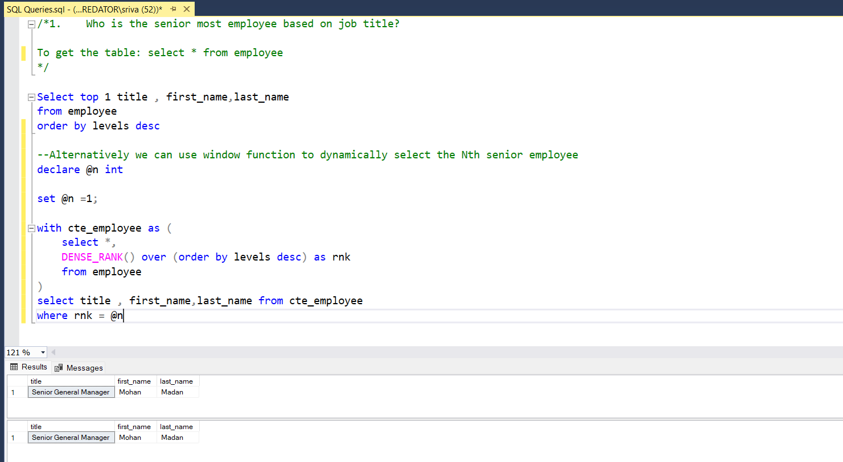

1. Which country has the most Invoices?

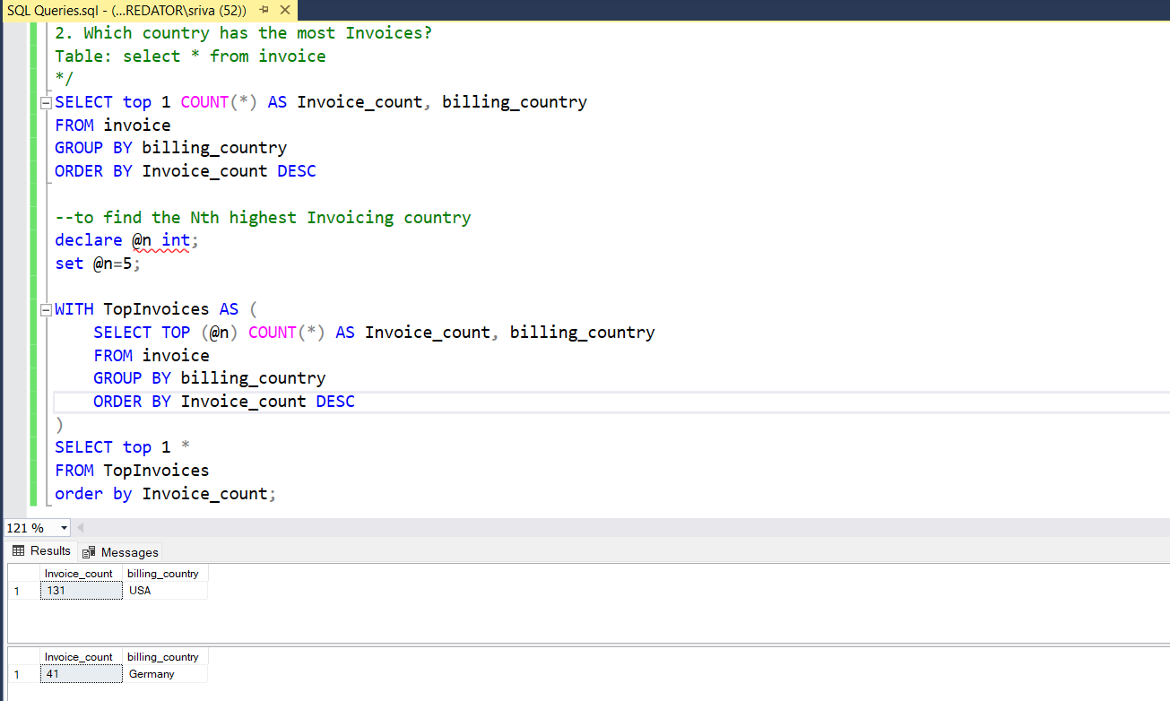

1. What are top 3 highest invoice values?

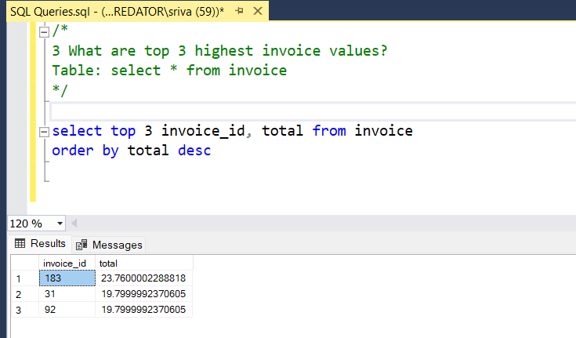

1. Write a query that returns one city that has the highest sum of invoice totals. Return both the city name & sum of all invoice totals

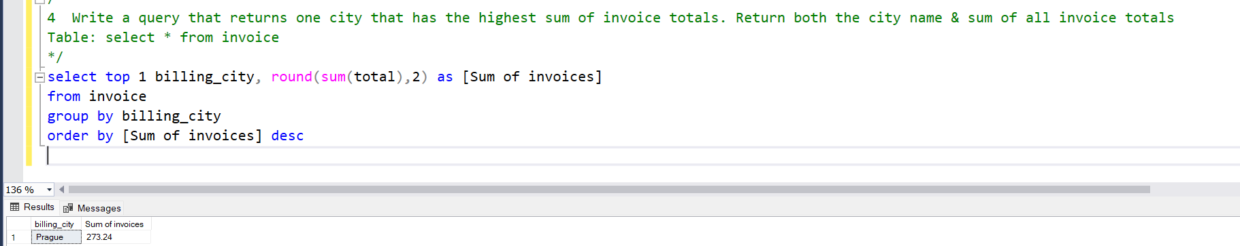

1. Write a query that returns the person who has spent the most money

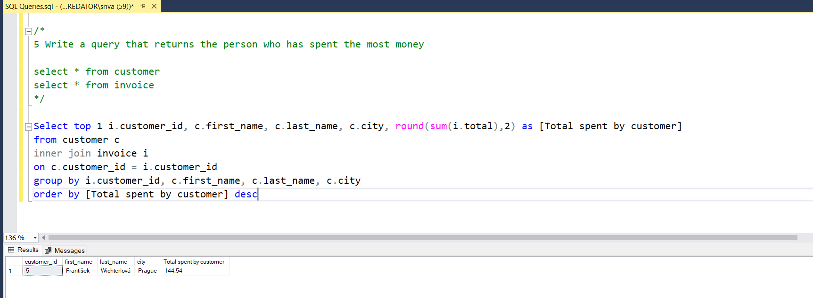

Question set 2 – Moderate

1. Write query to return the email, first name, last name, & Genre of all Rock Music listeners. Return your list ordered alphabetically by email starting with A

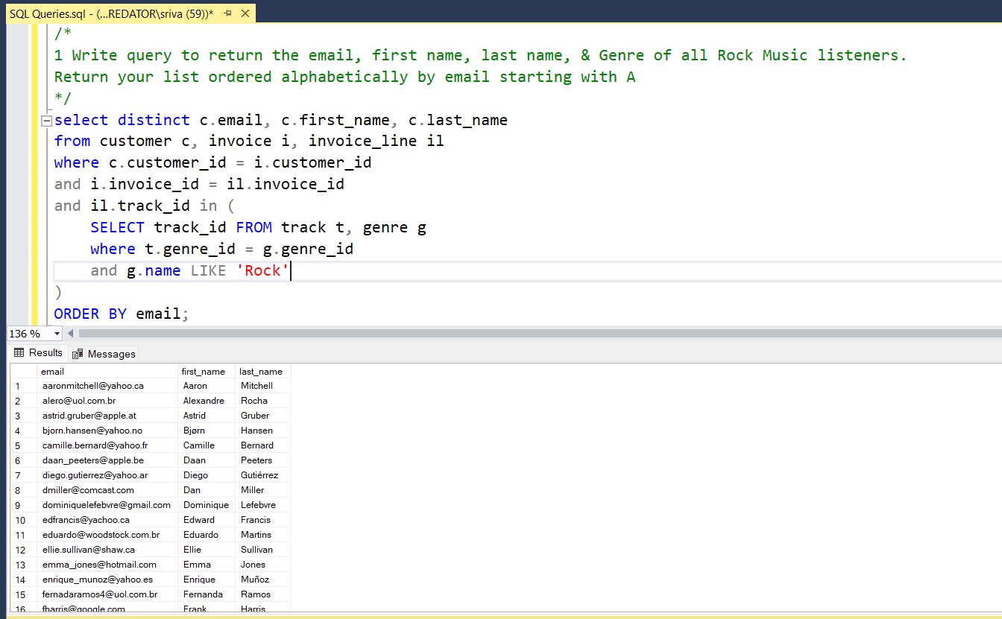  
  
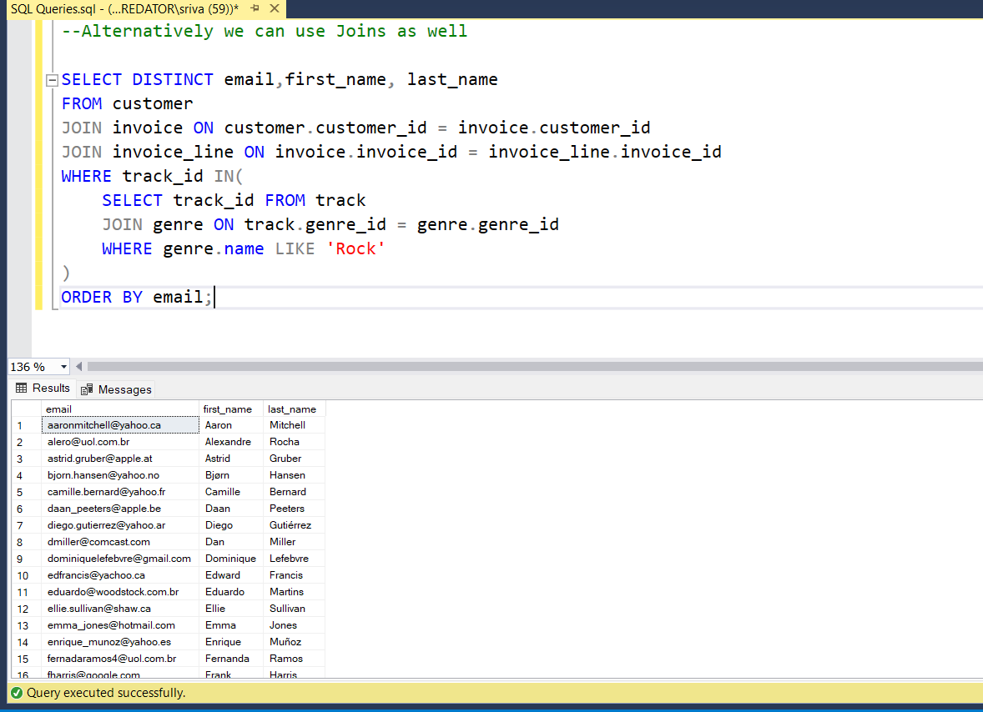

1. Write a query that returns the Artist name and total track count of the top 10 rock bands

